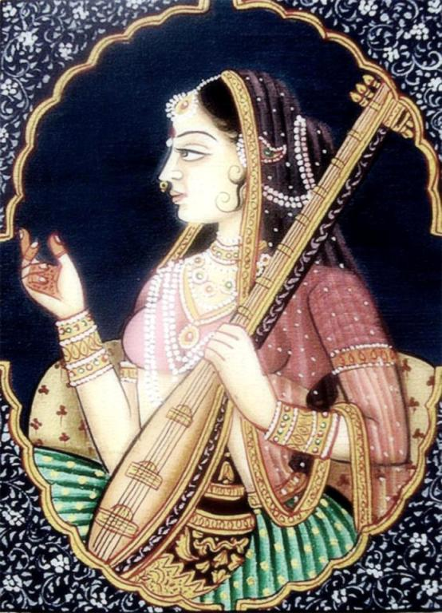
7-8.IX.2019 - WORKSHOP FOR WORKING WITH FEELINGS, BODY AND EMOTIONS THROUGH THE IMPROVEMENT OF VOICE VIBRATION
The whole cosmos, everything that exists in the universe, together with people consists of sound vibrations, called Naad. This means that it is the energy of sound in motion, rather than matter and particles, that are the building blocks of the universe.
Naad Yoga is a respectful way of approaching and responding to sound. In this context, sound and music have more meaning and a spiritual dimension than what we learn only through ordinary sensory properties. Sound and music are perceived here as a potential intermediary enabling achieving a deeper unity of both macro and micro-cosmos.
If we hear expressions of our own mind and soul, what causes them, we can go deeper into this process when it happens and direct it. When we communicate with our internal experience in his language - that is, the sound of emotions, with vibration, tone and rhythm - it becomes susceptible to our influence. By influencing our internal experience, we determine the way we express ourselves in the outside world.
Every day, we pay attention to the tone of voice of our interlocutors. Maybe we hear concern or anxiety in someone's voice or our own, even though the words don't express it?
This is because the sound carries the vibration we are at the moment. And the same can be the other way around: we can tune in to a different note through the right sound.
Widespread use of words such as “being in tune or not”, feeling good vibes, or “it sounds badly to me“ etc ... shows how language reflects the impact of a sound wave on our well-being. Let's learn to tune - first with ourselves and each other in the deepest sense of the word, and then, through communication - with the environment.
At this meeting, we will learn to receive sound through the body, not just hearing it. We will tune our body to distinguish between feelings related to different pitch and vibe color.
We will learn:
* system of chakras and kshetrams
* exercises for the navel, heart and pineal gland
* singing on different vowels
These workshops are about the inner journey of healing your relationship with your body and emotions using the ancient method of working with sound. About yogic work with energy and concentration, and clearing the subconscious. About an approach full of love and compassion for oneself as a being traveling in time and space ...
The Yoga Sound Workshop teaches you how to vibrate your spinal cord, how to listen to these sounds in your body and work with your voice, and through it with life energy - prana. For cleaning subtle information channels and increasing the level of transmission. This ancient technique renews and regulates the flow of Energy and gives a sense of deep peace. Thanks to special techniques of feeling the sound vibrations in the body - it is possible to sing not using hearing but the sense of touch.
It will be real yoga because the energy expenditure will be considerable and the state obtained will be harmonious.
PROGRAM:
SATURDAY, 10-19
Acquaintance with the method and stories about how specific sequences of tones sensitize specific places in the body and allow the release of the flow of energy blocked there. About how sound devoid of meaning and content, just the sound wave, resonates in us at different frequencies, arousing the corresponding feelings and guides us through the extra-mental experience of harmonizing and tuning.
• Basic Naad Yoga techniques - exercises for receiving and transmitting sound on the navel, heart and pineal gland, spine positioning exercises, a detailed lecture on the location of vibration places in the body ...
• Sensitization to sensations from the body, 7 basic sounds SA RE GA MA PA DHA NI SA, 12 halftones and 3 octaves,
SUNDAY, 10: 00-19: 00
• Today, we will especially devote time to singing with sounds, each vibrating with a different aspect of the body and mind, healing them: e.g. A - with the lungs, M - with the release of emotional tension ... etc.
• Understanding the concept of chakras and energy related to specific emotional states - these basics provide the basis for further exploration at a higher level, where we deal with the sublimation of animal impulses through the sound of voice and the improvement of singing techniques.
• Introduction to the rag system and a sense of "rasa" - various emotional moods, such as: devotion, peace, joy, lack of attachment, melancholy, etc., and the colors of sound and voice.
Through sound we learn to understand ourselves better, accept life and our past, all memory and limitations ... • (Own voice, Accompaniment from harmonium).
REGISTRATION, INFORMATION: Agnieszka Hari Kartar: 604 946 919, naadyoga@aquarianage.eu
DRIVING: Stefano Manfrin
PRICE: 450 PLN
LOCATION BOOKING by submitting to ovska@wp.pl and paying the deposit to the account given by email.
The exact address will be given before the workshop, depending on the size of the group of participants.

